Coppeliasim Installation Guide

- The robot simulator CoppeliaSim is based on a distributed control architecture: each object/model can be individually controlled via an embedded script, a plugin, a ROS or BlueZero node, a remote API client, or a custom solution. This makes CoppeliaSim very versatile and ideal for multi-robot applications. Controllers can be written in C/C++, Python, Java, Lua, Matlab or Octave.
- CoppeliaSim is used for fast algorithm development, factory automation simulations, fast prototyping and verification, robotics related education, remote monitoring, safety double-checking, as digital twin, and much more. You can find a feature overview here.
- It can be used as a stand-alone application or can easily be embedded into a main client application: its small footprint and elaborate API makes CoppeliaSim an ideal candidate to embed into higher-level applications

1.1 For Windows Users:
- Installation steps for Windows:
- Download CoppeliaSim_Edu_V4_10_0_rev0 for Windows 64-bit OS from here(238 MB)

- Navigate to the downloaded .exefile and double-click it to install the software.

- Once the installation is complete, a shortcut icon to launch the software would have been created on your Desktop. Double-click to launch it. CoppeliaSim will open as shown in Figure 1 with the default scene loaded.

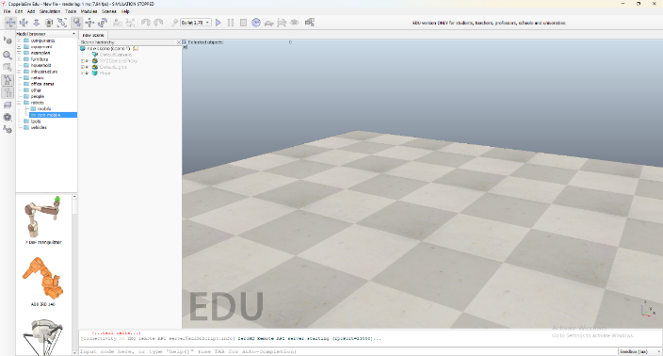
Figure 1
- Explore CoppeliaSIm
1. Coppelia Robotics
2. CoppeliaSim User Manual

